You can find a detailed tutorial and sample code at:

[learn.sparkfun.com/tutorials/digital-sandbox-arduino-companion](https://learn.sparkfun.com/tutorials/digital-sandbox-arduino-companion)

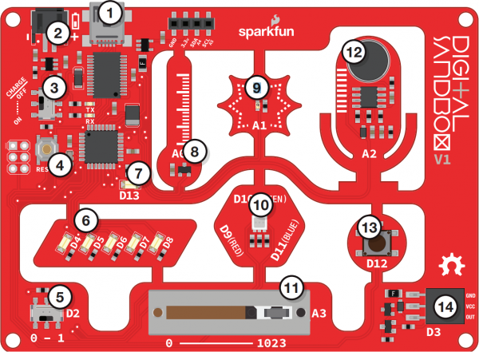

1. USB port to plug in your cord for uploading code or powering
2. JST connector to permit powering with LiPo batteries
3. Slide switch for charging – Determines whether a battery plugged into the JST connector charges when the Sandbox is connected to a computer.
4. **Reset Button** – Resets board (restarts code from start).
5. **Slide Switch (Pin 2)** – On/off (digital) input
6. **LEDs, white (Pins 4-8)**
7. **LED, red (Pin 13)**
8. **Temperature Sensor (Pin A0)** – Measures ambient temperature.
9. **Light Sensor (Pin A1)** – Measures the amount of light hitting the sensor.
10. **RGB LED (Pins 9/10/11)** – An RGB LED. Contains individual channels (red/green/blue) that can be combined to create full-spectrum color.
11. **Slide Potentiometer (Pin A3)** – Slides to give values from 0 to 1023
12. **Microphone (Pin A2)** – Measures how loud something is
13. **Push Button (Pin 12)** – On/off (digital) momentary input
14. **Add-on Header (Pin 3)** – Three-pin header for add-ons. Example add-ons are servos, motors and buzzers